- For (a+Λ)(a*b+ba*)(a*+ Λ )* to be the regular expression of (L₁»L₂^{c} ) « ( L₁^{c}» L₂ ), it is required to find whether this language accepts any string or not?
  - After removing all *s the RE will be (a+ Λ )(ab+ba)(a+ Λ )
  - After separating the left part from + and the + itself the RE will be aaba
  - As this language contains atleast aaba as its word, so this language is not empty.
  - After separating the right part from + and the + itself the RE will be abab

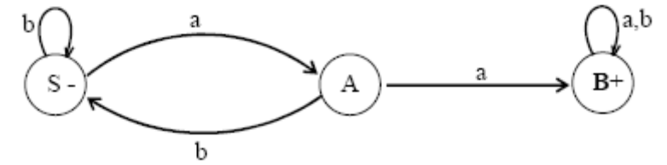
2.

CFG corresponding to the above FA may be :
- S → aS|bA
- A → aB|bS|aA
- A → bB|aS
- B → aB|bB|L

3. what the meaning of A semiword ?
a. A semiword is not a string of terminals (may be none) concatenated with exactly one nonterminal on the right i.e. a semiword, in general, is of the following form (terminal)(terminal)… (terminal)(nonterminal)
b. A semiword is a string of terminals (may be none) concatenated with exactly one terminal on the right i.e. a semiword, in general, is of the following form (terminal)(terminal)… (terminal)(nonterminal)
c. A semiword is a string of terminals (may be none) concatenated with exactly one nonterminal on the right i.e. a semiword, in general, is of the following form (nonterminal)(nonterminal)… (terminal)(nonterminal)
d. A semiword is a string of terminals (may be none) concatenated with exactly one nonterminal on the right i.e. a semiword, in general, is of the following form (terminal)(terminal)… (terminal)(nonterminal)

- what the meaning of a word ?
  - A word is a string of terminals.
  - A word is not a string of terminals.
  - A word are string of terminals and not string terminals .
  - Λ is also a word.

- Consider the following CFG
S → aaS|bbS| Λ
The TG accepting the language generated by the above CFG is given below

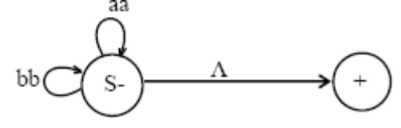
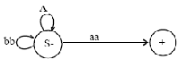
- c.

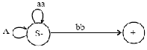
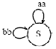
- d.

- why are The CFG S → aaS|bbS|Λ is a regular grammar...
  - It may be observed that the above CFG generates the language of strings expressed by the RE (ab+bb)*
  - It may be observed that the above CFG generates the language of strings expressed by the RE (aa+ab)*
  - It may be observed that the above CFG generates the language of strings expressed by the RE (aa+ab)*
  - It may be observed that the above CFG generates the language of strings expressed by the RE (aa+bb)*

- which the following is not the method to build a TG from the given regular grammar…
  - Define the states, of the required TG, equal in number to that of nonterminals of the given regular grammar.
  - The initial state should correspond to the terminal S.
  - An additional state is also defined to be the final state.
  - For every production of the given regular grammar, there are two possibilities for the transitions of the required TG

8. Consider the following CFG
S → X|b, X → aX
then following will be the total language tree of the above CFG

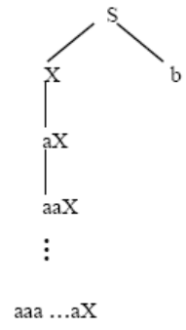
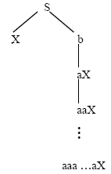
- c.

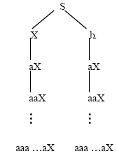
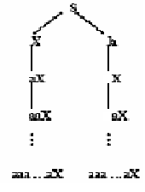
- d.

      - it is possible to write its regular expression…
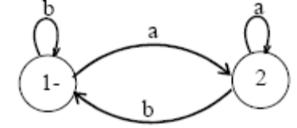
a.

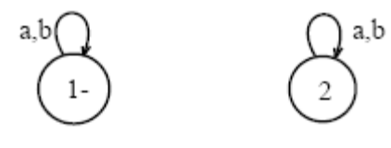
b.

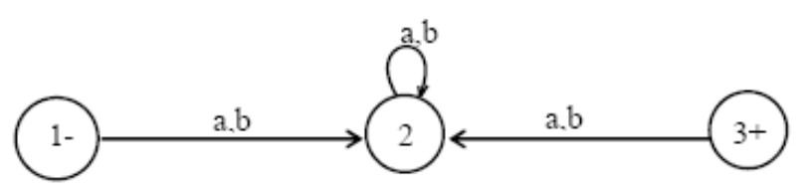
c.

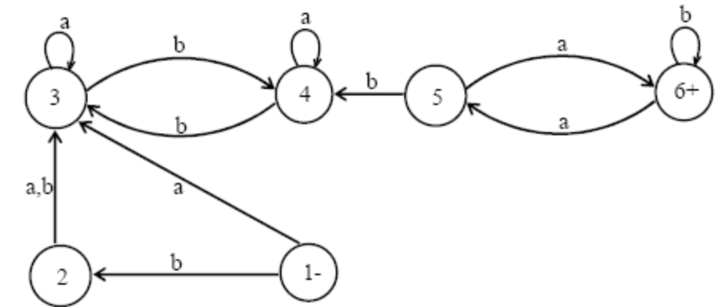
d.

10. what is Decision procedure…
a. A problem that has decision procedure is called decidable problem e.g. the following problems
b. The two regular expressions define the same language.
c. The two FAs are equivalent.
d. If an effectively solvable problem has answer in yes or no, then this solution is called decision procedure.

